Name: Anil Sunil Parmar
Roll No: 113

HTML Practical Assignment 3

Code :
<!DOCTYPE html>
<html>
<head>
<title>HTML Tables Assignment</title>
</head>
<body>

<table border="1" cellpadding="3">
<tr>
<th colspan="4"><font color="#C00000" size="4">Table using Colspan and Rowspan</font></th>
</tr>
<tr>
<th colspan="4"><font size="4">Khanewal Self Store</font></th>
</tr>
<tr>
<th><b>Item/Desc</b></th>
<th><b>QTY</b></th>
<th><b>Price/Unit</b></th>
<th><b>Total</b></th>
</tr>
<tr>
<td>Sugger</td>
<td>5kg</td>
<td>50</td>
<td>250</td>
</tr>
<tr>
<td>Cooking Oil</td>
<td>2kg</td>
<td>200</td>
<td>400</td>
</tr>
<tr>
<td>Soap</td>
<td>4 Pices</td>
<td>40</td>
<td>160</td>
</tr>
<tr>
<td colspan="3">Sub Total</td>
<td>810</td>
</tr>
<tr>
<td>Tax</td>
<td></td>
<td>5%</td>
<td>41</td>
</tr>
<tr>
<td colspan="3">Total Bill</td>
<td>851</td>
</tr>
</table>

<br><br>

<table border="1" cellpadding="5">
<tr align="center" bgcolor="#40E0D0">
<th><b>Device</b></th>
<th><b>Brand</b></th>
<th colspan="2"><b>Specifications</b></th>
</tr>
<tr align="center">
<td rowspan="3" align="left">Smartphone</td>
<td rowspan="3" align="left">Apple</td>
<th bgcolor="#FFD700"><b>Model</b></th>
<th bgcolor="#FFD700"><b>Storage</b></th>
</tr>
<tr align="center">
<td>iPhone 12 Pro</td>
<td>256GB</td>
</tr>
<tr align="center">
<td>iPhone SE</td>
<td>128GB</td>
</tr>
<tr>
<td>Laptop</td>
<td>HP</td>
<td colspan="2">15.6" Display</td>
</tr>
<tr>
<td>Tablet</td>
<td>Samsung</td>
<td colspan="2">10.5" Display</td>
</tr>
</table>
<p><font size="2" face="sans-serif">A complex table</font></p>

<br><br>

<table border="1" cellpadding="5" cellspacing="0" width="600">
<tr>
<td colspan="3">Invoice #123456789</td>
<td>14 January 2025</td>
</tr>
<tr>
<td colspan="2" valign="top">
Pay to:<br>
Acme Billing Co.<br>
123 Main St.<br>
Cityville, NA 12345
</td>
<td colspan="2" valign="top">
Customer:<br>
John Smith<br>
321 Willow Way<br>
Southeast Northwestershire, MA 54321
</td>
</tr>
<tr>
<td><b>Name / Description</b></td>
<td><b>Qty.</b></td>
<td><b>@</b></td>
<td><b>Cost</b></td>
</tr>
<tr>
<td>Paperclips</td>
<td>1000</td>
<td>0.01</td>
<td>10.00</td>
</tr>
<tr>
<td>Staples (box)</td>
<td>100</td>
<td>1.00</td>
<td>100.00</td>
</tr>
<tr>
<td colspan="3">Subtotal</td>
<td>110.00</td>
</tr>
<tr>
<td colspan="2">Tax</td>
<td>8%</td>
<td>8.80</td>
</tr>
<tr>
<td colspan="3"><b>Grand Total</b></td>
<td><b>$ 118.80</b></td>
</tr>
</table>

<br><br>

<table border="0" cellpadding="5" cellspacing="5">
<tr>
<td><img src=" C:\Users\parma\Downloads\AnilMca\img1" width="130" height="130" alt="Landscape 1"></td>
<td><img src=" C:\Users\parma\Downloads\AnilMca\img2" width="130" height="130" alt="Landscape 2"></td>
<td><img src=" C:\Users\parma\Downloads\AnilMca\img3 " width="130" height="130" alt="Landscape 3"></td>
<td><img src=" C:\Users\parma\Downloads\AnilMca\img4 " width="130" height="130" alt="Landscape 4"></td>
</tr>
<tr>
<td><img src=" C:\Users\parma\Downloads\AnilMca\img5 " width="130" height="130" alt="Landscape 5"></td>
<td><img src=" C:\Users\parma\Downloads\AnilMca\img6" width="130" height="130" alt="Landscape 6"></td>
<td><img src=" C:\Users\parma\Downloads\AnilMca\img7" width="130" height="130" alt="Landscape 7"></td>
<td><img src=" C:\Users\parma\Downloads\AnilMca\img8" width="130" height="130" alt="Landscape 8"></td>
</tr>
<tr>
<td><img src=" C:\Users\parma\Downloads\AnilMca\img9" width="130" height="130" alt="Landscape 9"></td>
<td><img src=" C:\Users\parma\Downloads\AnilMca\img10" width="130" height="130" alt="Landscape 10"></td>
<td><img src=" C:\Users\parma\Downloads\AnilMca\img11" width="130" height="130" alt="Landscape 11"></td>
<td><img src="C:\Users\parma\Downloads\AnilMca\img12" width="130" height="130" alt="Landscape 12"></td>
</tr>
</table>
<br>
</body>
</html>

Outputs : (practicle3.html)
Q1. Table using Colspan and Rowspan
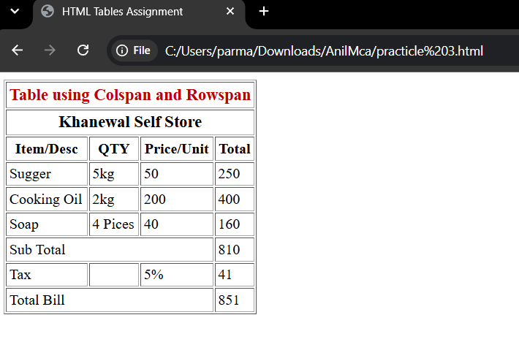
Q2.Mobile device Specification and Description
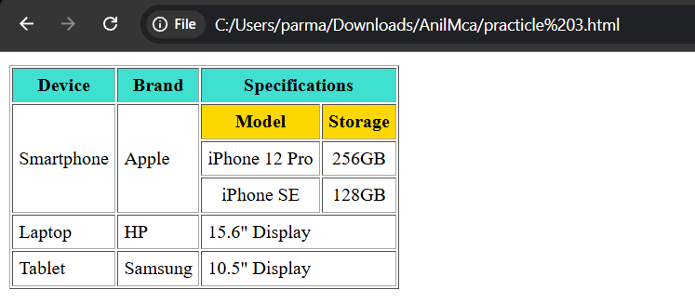
Q3. Product Invoice
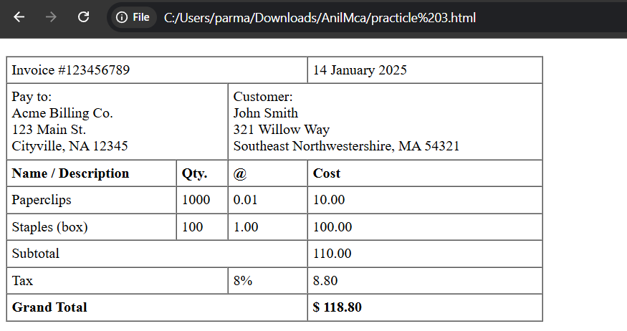
Q4.Images in Rows and Columns
